Contents

**su:** 2

**sudo:** 2

**How to set/change root password:** 2

**su: substitute user** 2

**su - : su with hyphen** 2

**sudo su:** 3

**sudo su - : with hyphen** 3

**sudo -i** 3

**sudo -s** 3

# **su:**

* It allows current user to become root user.
* It will change current (local) user environment to root user environment.
* Root password is needed.

# **sudo:**

* It runs single command with root privileges.
* No need of root password but current user’s password is needed before running command as root user.

# **How to set/change root password:**

Command: sudo passwd root

# **su: substitute user**

* It allows current user to act and run commands as root user.
* To run commands, you must run command with sudo otherwise command will not run.
* It keeps current user’s environment.
* No need of root user’s password.
* While using sudo, new user’s password must be known.

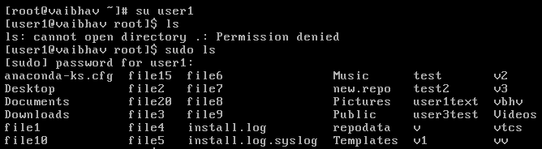

# **su - : su with hyphen**

* It allows current user to act and run commands as root user.
* No need of sudo.
* It keeps new user’s environment.
* No need of root user’s password

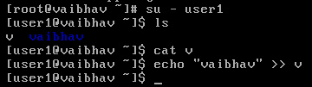

# **sudo su:**

* It is same as su.

# **sudo su - : with hyphen**

* It is same as su - .

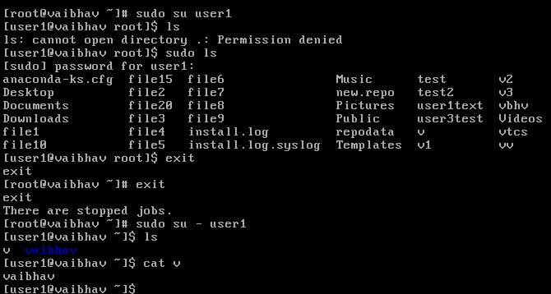

# **sudo -i**

* -i flag allows user to get a root environment without having to know the root password.

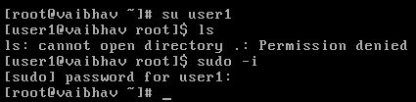

# **sudo -s**

* -s flag allows to read $SHELL variable of the current user executing commands.
* It will gain root but will not change user environment.
* This best when user doesn’t want to touch root at all but just wants root shell for easy command execution.